

**COMSATS UNIVERSITY ISLAMABAD, ABBOTTABAD**

Artificial Intelligence

Assignment # 02

***Submitted by:***

Laiba Binte Tahir FA21-BSE-019

***Submitted to:***

Dr. Mubshir Ahmed

Q no 1.

**Day Outlook Temp. Humidity Wind Decision**

|  |  |  |  |  |  |
| --- | --- | --- | --- | --- | --- |
| D1 | Sunny | Hot | High | Weak | No |
| D2 | Sunny | Hot | High | Strong | No |
| D3 | Overcast | Hot | High | Weak | Yes |
| D4 | Rain | Mild | High | Weak | Yes |
| D5 | Rain | Cool | Normal | Weak | Yes |
| D6 | Rain | Cool | Normal | Strong | No |
| D7 | Overcast | Cool | Normal | Strong | Yes |
| D8 | Sunny | Mild | High | Weak | No |
| D9 | Sunny | Cool | Normal | Weak | Yes |
| D10 | Rain | Mild | Normal | Weak | Yes |
| D11 | Sunny | Mild | Normal | Strong | Yes |
| D12 | Overcast | Mild | High | Strong | Yes |
| D13 | Overcast | Hot | Normal | Weak | Yes |
| D14 | Rain | Mild | High | Strong | No |

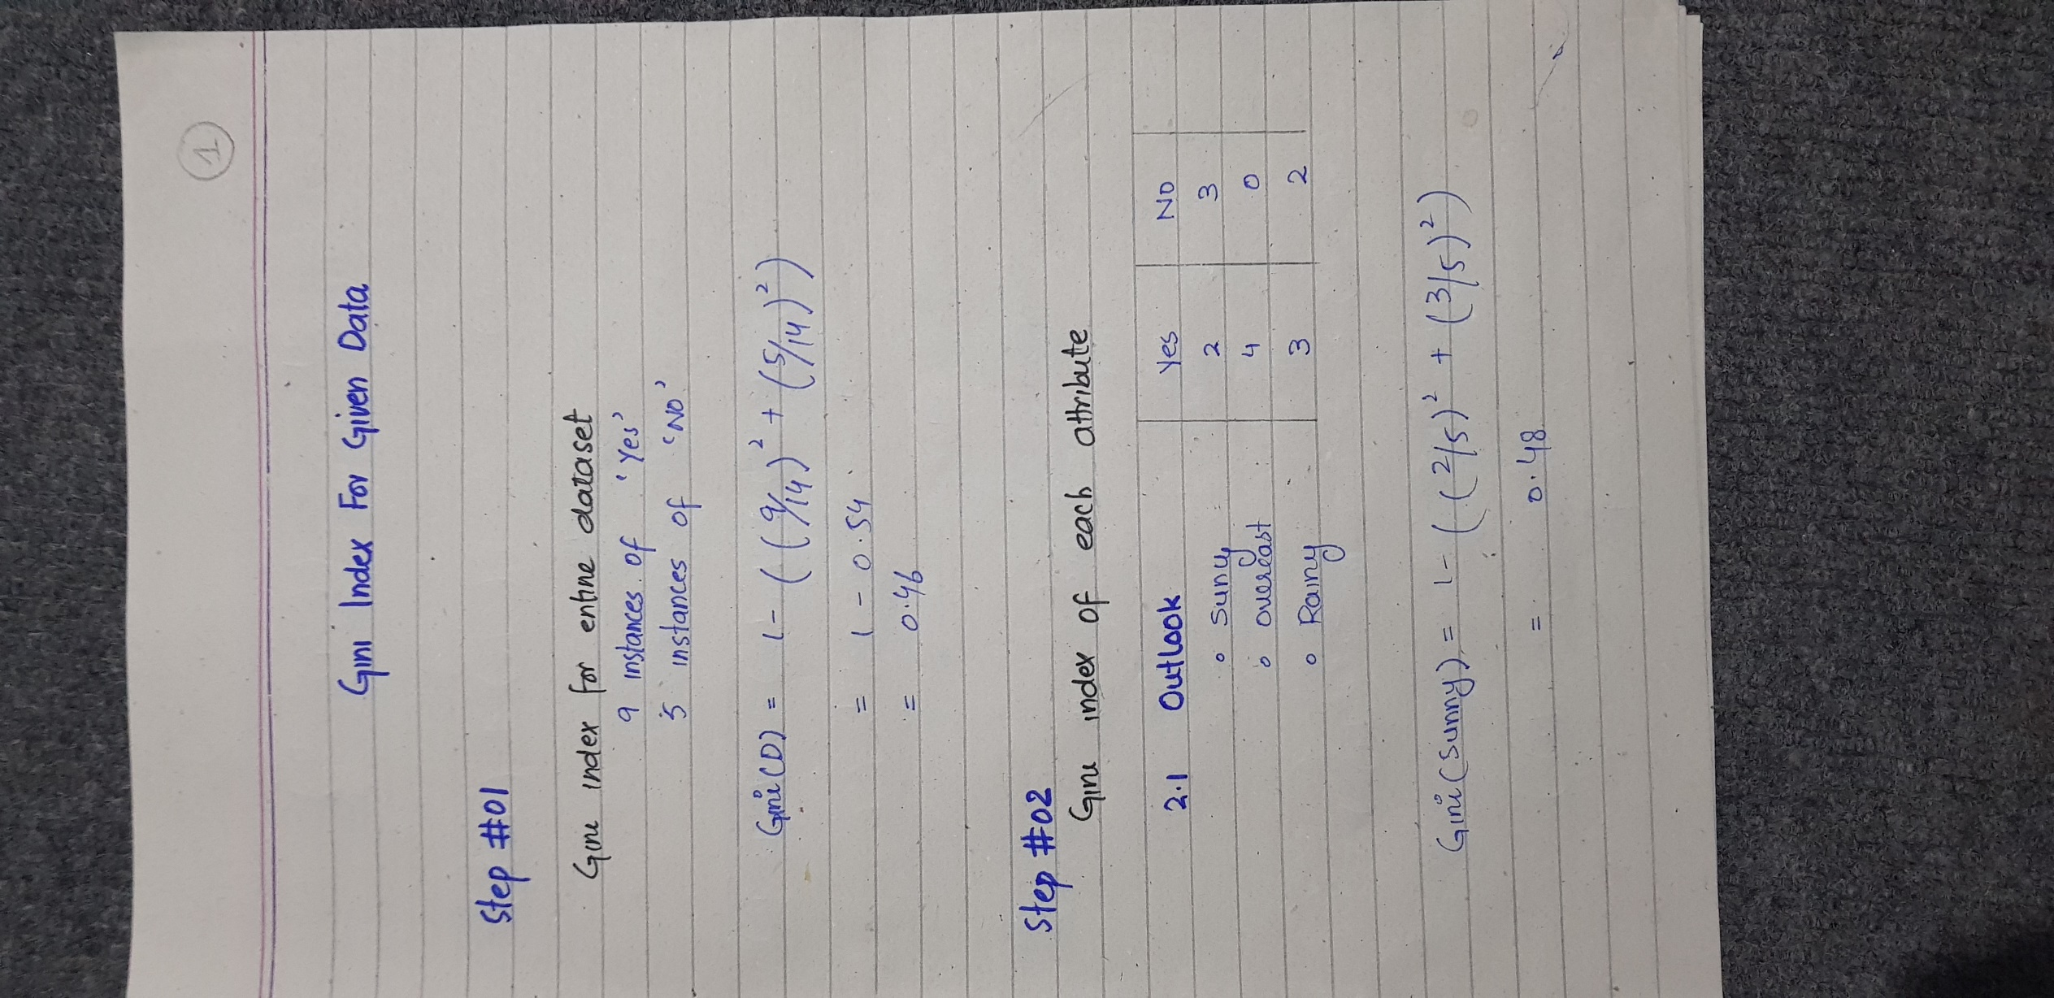

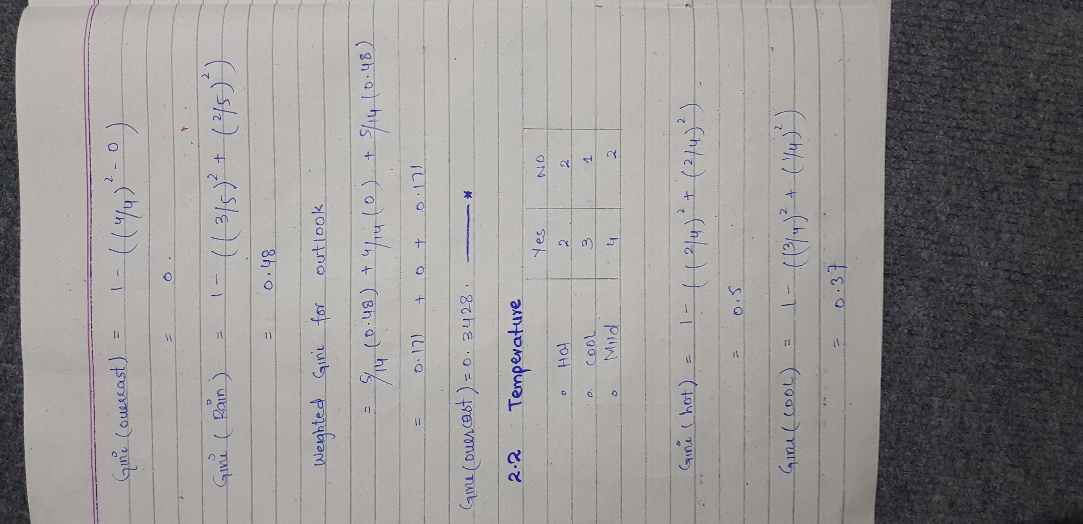

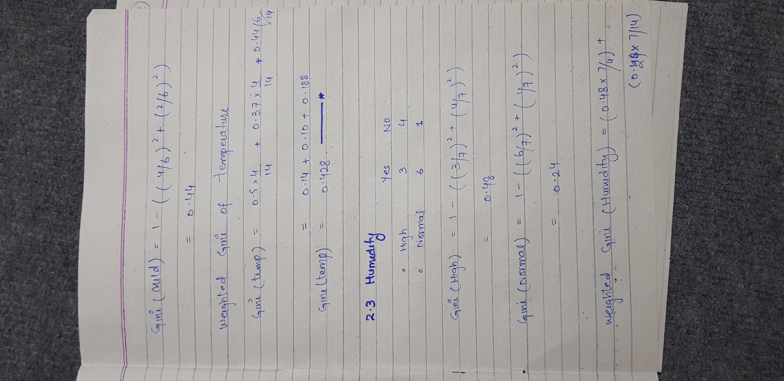

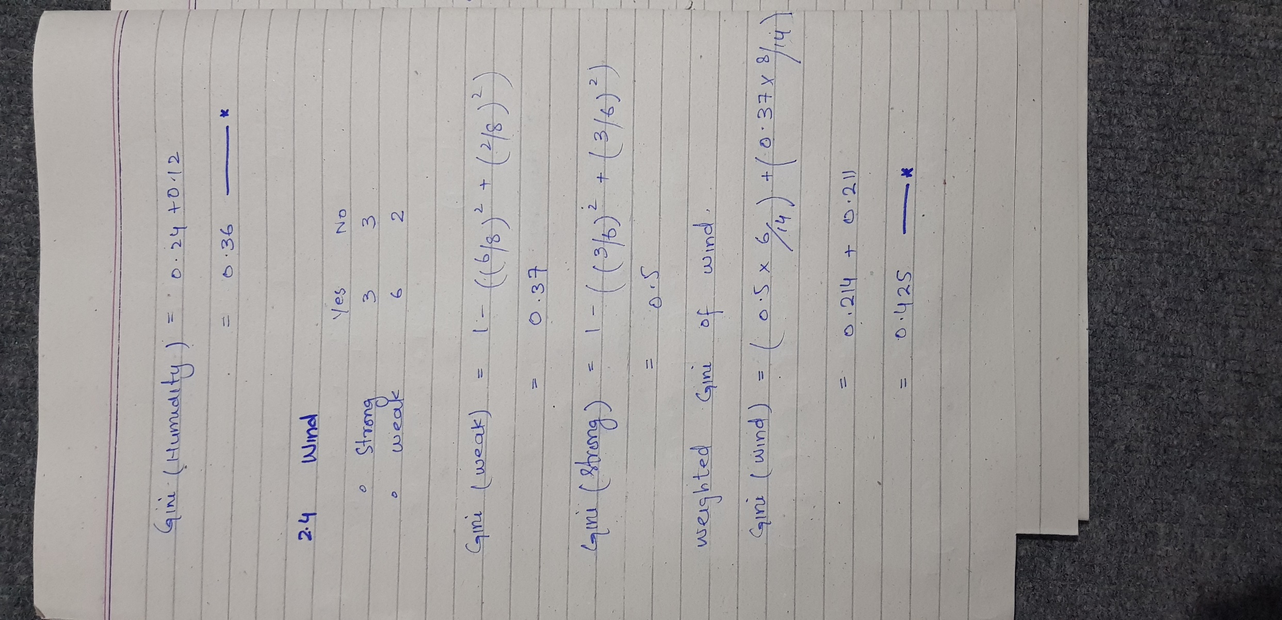

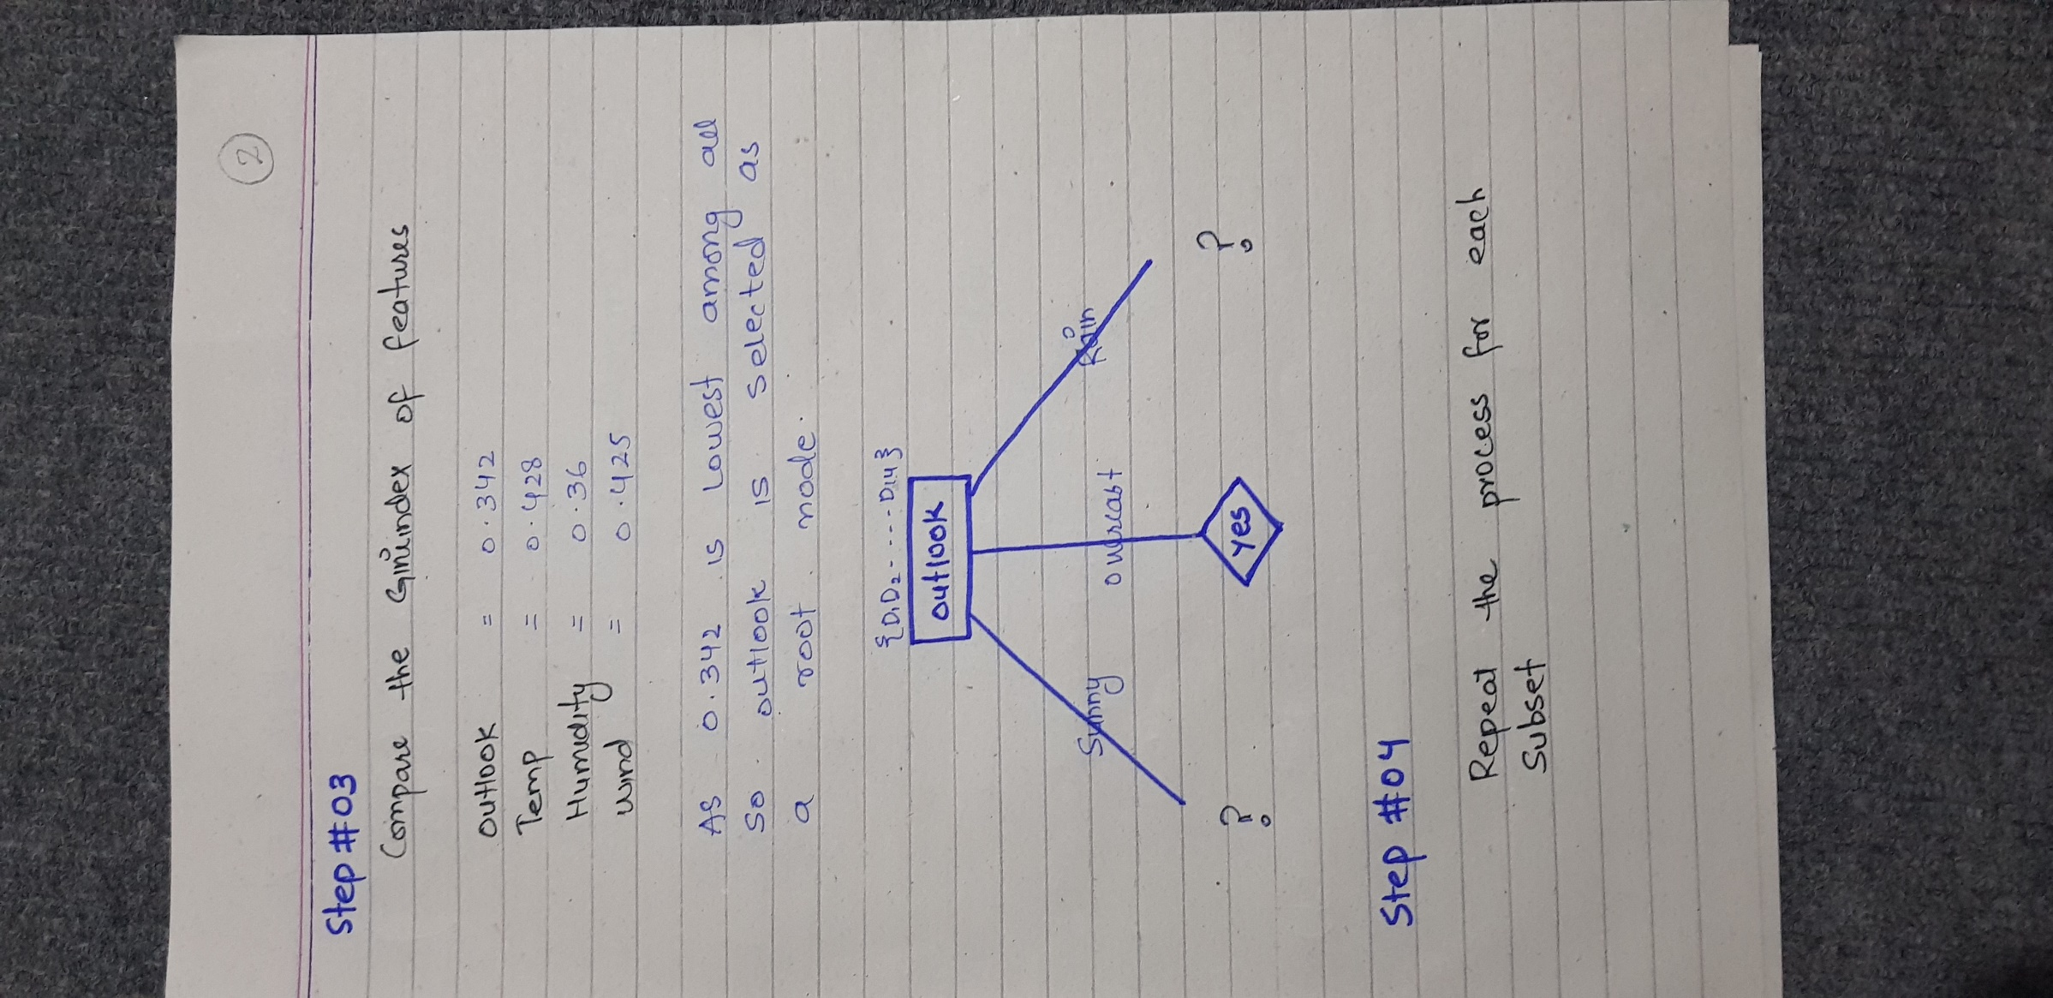

**Day Outlook Temp. Humidity Wind Decision**

|  |  |  |  |  |  |
| --- | --- | --- | --- | --- | --- |
| D3 | Overcast | Hot | High | Weak | Yes |
| D7 | Overcast | Cool | Normal | Strong | Yes |
| D12 | Overcast | Mild | High | Strong | Yes |
| D13 | Overcast | Hot | Normal | Weak | Yes |
|  |  |  |  |  |  |
|  |  |  |  |  |  |
| D1 | Sunny | Hot | High | Weak | No |
| D2 | Sunny | Hot | High | Strong | No |
| D8 | Sunny | Mild | High | Weak | No |
| D9 | Sunny | Cool | Normal | Weak | Yes |
| D11 | Sunny | Mild | Normal | Strong | Yes |

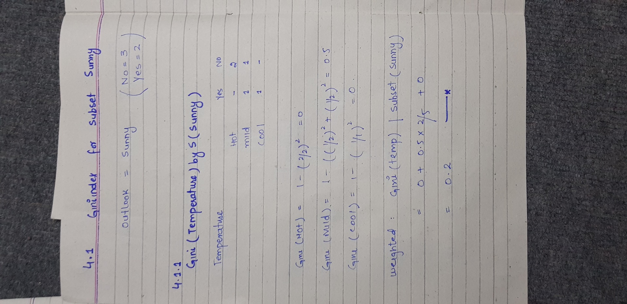

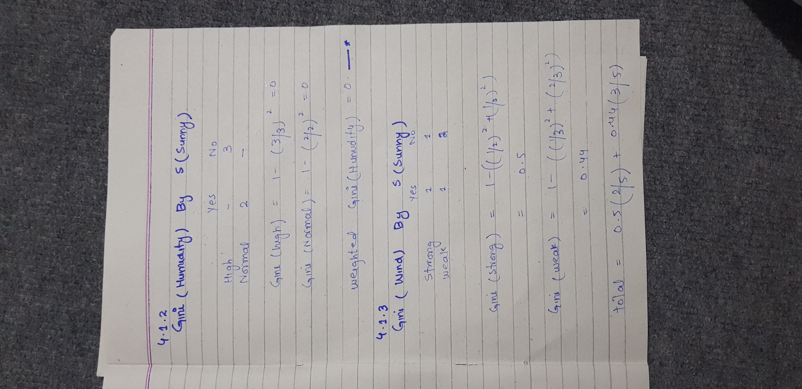

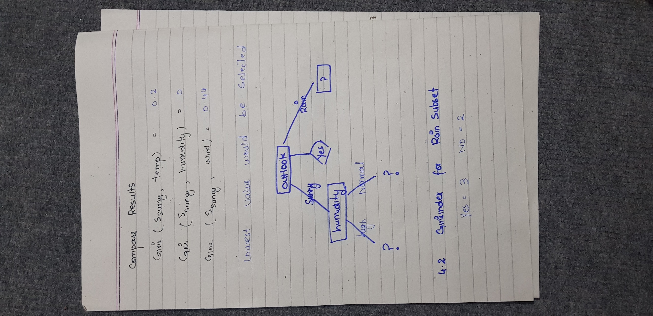

|  |  |  |  |  |  |
| --- | --- | --- | --- | --- | --- |
| D4 | Rain | Mild | High | Weak | Yes |
| D5 | Rain | Cool | Normal | Weak | Yes |
| D6 | Rain | Cool | Normal | Strong | No |
| D10 | Rain | Mild | Normal | Weak | Yes |
| D14 | Rain | Mild | High | Strong | No |

